**NAME- Aryaman Chokhani**

**UID- 2021300020**

**AIM:**

Design Interactive Dashboards and Storytelling using Tableau / Power BI / R (Shiny) / Python (Streamlit/Flask) / D3.js to be performed on the dataset - Disease spread / Healthcare

* Create interactive dashboard - Write observations from each chart given below
* (Advanced - Word chart, Box and whisker plot, Violin plot, Regression plot (linear and nonlinear), 3D chart, Jitter, Line, Area, Waterfall, Donut, Tree map, Funnel
* Basic - Bar chart, Pie chart, Histogram, Timeline chart, Scatter plot, Bubble plot)

**DATASET:**

<https://www.kaggle.com/datasets/maheshdadhich/us-healthcare-data>  
  
The **US Healthcare Analytics Power BI Insights** repository uses a dataset that focuses on key metrics within the U.S. healthcare system from 2019 to 2020. This dataset likely includes information related to **hospital performance**, **patient outcomes**, **monthly healthcare expenses**, and **payer-provider relationships**​.

The dataset would typically encompass:

* **Patient demographics** (age, gender, location, etc.)
* **Hospital performance metrics** (admissions, discharges, readmissions, etc.)
* **Financial metrics** (payer information, expenses, and reimbursements)
* **Outcome data** (treatment effectiveness, recovery times)

DASHBOARD:

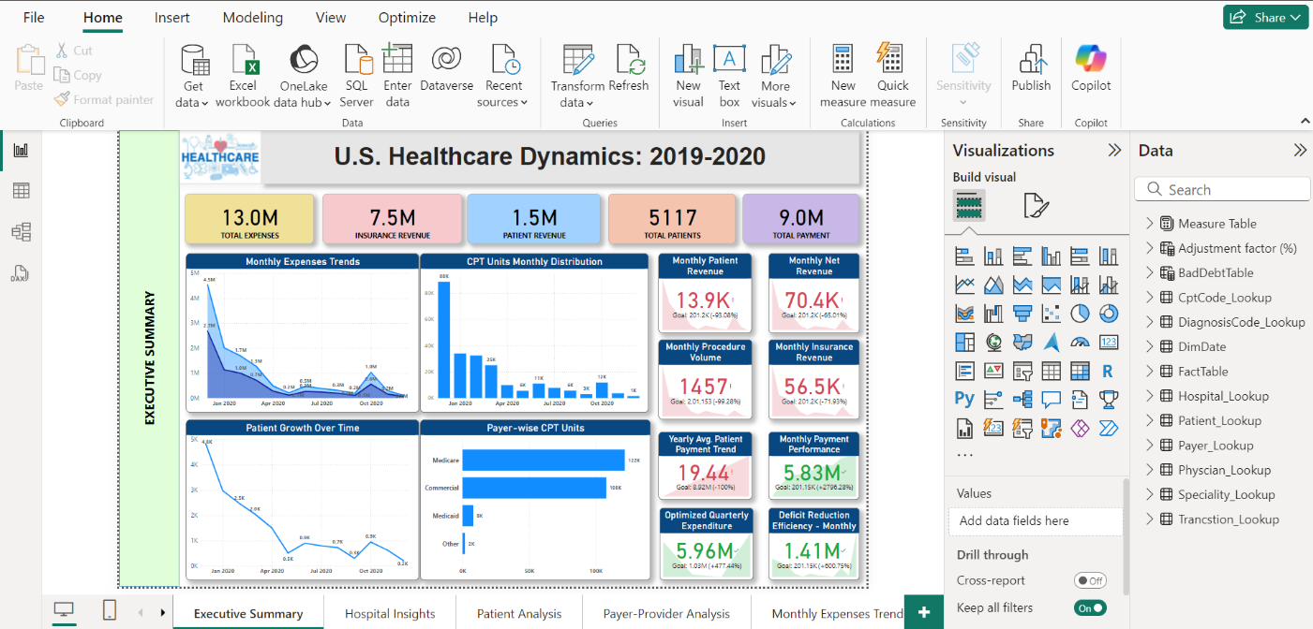

**1. Monthly Expenses Trends (Area Chart)**

* **X-Axis**: Time (Months of 2020, e.g., Jan 2020, Apr 2020, Jul 2020, Oct 2020)
* **Y-Axis**: Gross Expense and Insurance Payment
* **Summary**: This area chart visualizes the **monthly healthcare expenses** over time, from January to December 2020. It shows a peak in expenses at the beginning of the year, with a downward trend throughout most of the year, followed by a slight increase toward the end of the year.

**2. Patient Growth Over Time (Line Chart)**

* **X-Axis**: Time (Months of 2020)
* **Y-Axis**: Number of Patients (in Thousands)
* **Summary**: This line chart tracks the **growth in patient numbers over time**. It indicates a sharp decline in patient numbers at the beginning of 2020, followed by a more stabilized, fluctuating pattern toward the end of the year.

**3. CPT Units Monthly Distribution (Histogram)**

* **X-Axis**: Time (Months of 2020)
* **Y-Axis**: CPT Units (Count in Thousands)
* **Summary**: This **bar chart** visualizes the distribution of **CPT (Current Procedural Terminology) units** each month. It shows a high number of units at the start of the year, dropping significantly around April, with a slow recovery throughout the remaining months.

**4. Payer-wise CPT Units (Horizontal Bar Chart)**

* **X-Axis**: CPT Units (Count in Thousands)
* **Y-Axis**: Payer Types (Medicare, Commercial, Medicaid, Other)
* **Summary**: This bar chart breaks down the **CPT unit counts** by payer type, showing that **Medicare** and **Commercial** payers have significantly higher CPT unit counts compared to **Medicaid** and **Other** payers.

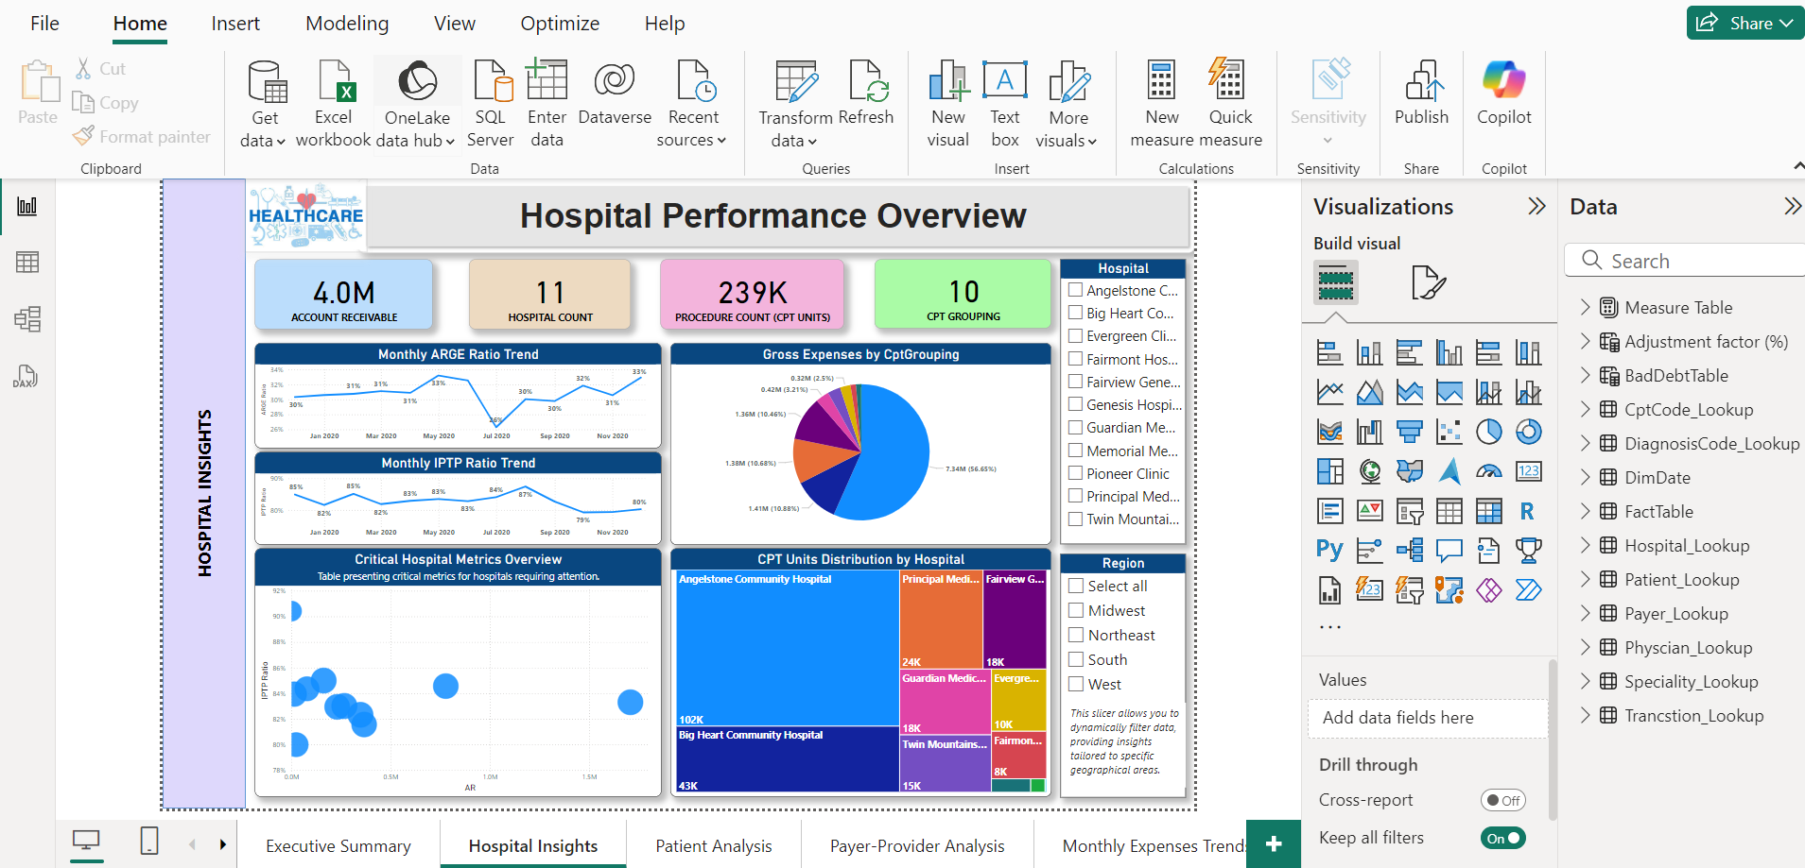

**1. Monthly ARGE Ratio Trend (Timeline Chart)**

* **X-Axis**: Time (Months of 2020, e.g., Jan 2020, Mar 2020)
* **Y-Axis**: ARGE Ratio (%)
* **Summary**: This chart visualizes the **ARGE ratio trend** over time for the year 2020. It shows variations in the ratio, which gives insights into hospital performance metrics.

**2. Monthly IPTP Ratio Trend (Timeline Chart)**

* **X-Axis**: Time (Months of 2020)
* **Y-Axis**: IPTP Ratio (%)
* **Summary**: This chart provides insight into the **IPTP ratio trend** over time. It shows fluctuations in the ratio, which can indicate changes in hospital efficiency and patient outcomes.

**3. Gross Expenses by CPT Grouping (Pie Chart)**

* **Legend**: CPT Grouping Categories
* **Values**: Gross Expenses (in Millions)
* **Summary**: This pie chart shows how **gross expenses** are distributed among different **CPT groupings**. It helps to identify the major categories of expenses in hospitals.

**4. Critical Hospital Metrics Overview (Bubble Chart)**

* **X-Axis**: Account Receivable (AR)
* **Y-Axis**: IPTP Ratio (%)
* **Bubble Size**: Number of Patients (or other hospital performance metrics)
* **Summary**: This scatter plot visualizes the **relationship between AR and IPTP ratio**, with bubble sizes representing another metric (e.g., number of patients). It’s useful for spotting outliers and key performance trends.

**5. CPT Units Distribution by Hospital (Tree map)**

* **Category**: Hospital Name
* **Values**: CPT Units
* **Summary**: The tree map provides a visual breakdown of **CPT unit distribution by hospital**. Larger boxes represent hospitals with more CPT units, helping to quickly assess performance across multiple facilities.

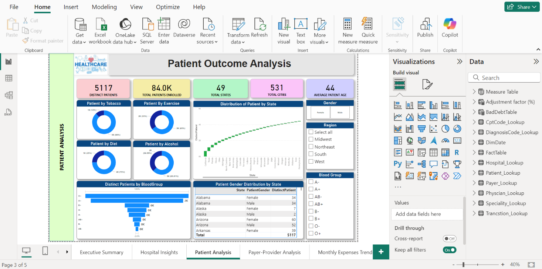

**1. Patient by Tobacco (Donut Chart)**

* **X-Axis**: Not applicable (Donut chart)
* **Y-Axis**: Number of Patients (Grouped by tobacco usage: Yes/No)
* **Summary**: This donut chart shows the percentage of patients who use tobacco. It visually represents the proportion of tobacco users versus non-users among the patient population.

**2. Patient by Exercise (Donut Chart)**

* **X-Axis**: Not applicable (Donut chart)
* **Y-Axis**: Number of Patients (Grouped by exercise frequency: Yes/No)
* **Summary**: This donut chart displays the percentage of patients who engage in regular exercise versus those who do not. It helps understand exercise habits in the patient group.

**3. Patient by Diet (Donut Chart)**

* **X-Axis**: Not applicable (Donut chart)
* **Y-Axis**: Number of Patients (Grouped by diet choices)
* **Summary**: This chart illustrates the proportion of patients who follow a specific diet. It provides insights into dietary preferences among patients.

**4. Patient by Alcohol (Donut Chart)**

* **X-Axis**: Not applicable (Donut chart)
* **Y-Axis**: Number of Patients (Grouped by alcohol consumption)
* **Summary**: This donut chart shows the percentage of patients who consume alcohol, offering an overview of alcohol usage within the patient demographic.

**5. Distribution of Patients by State (Waterfall Chart)**

* **X-Axis**: State
* **Y-Axis**: Number of Patients (Cumulative distribution)
* **Summary**: This line chart shows the cumulative distribution of patients across various states. It helps in understanding which states have higher patient populations and how the distribution is spread geographically.

**6. Distinct Patients by Blood Group (Funnel Chart)**

* **X-Axis**: Blood Group
* **Y-Axis**: Number of Patients
* **Summary**: This bar chart categorizes patients based on their blood groups, displaying the distribution of distinct patients across different blood types. It helps in visualizing the prevalence of various blood types in the patient population.

**7. Patient Gender Distribution by State (Word Chart)**

* **X-Axis**: Not applicable (Table format)
* **Y-Axis**: Not applicable (Table format)
* **Summary**: This table shows the distribution of male and female patients in each state. It provides detailed insights into the gender breakdown across different regions, showing the distinct patient counts by gender and state.

**ER DIAGRAM:**

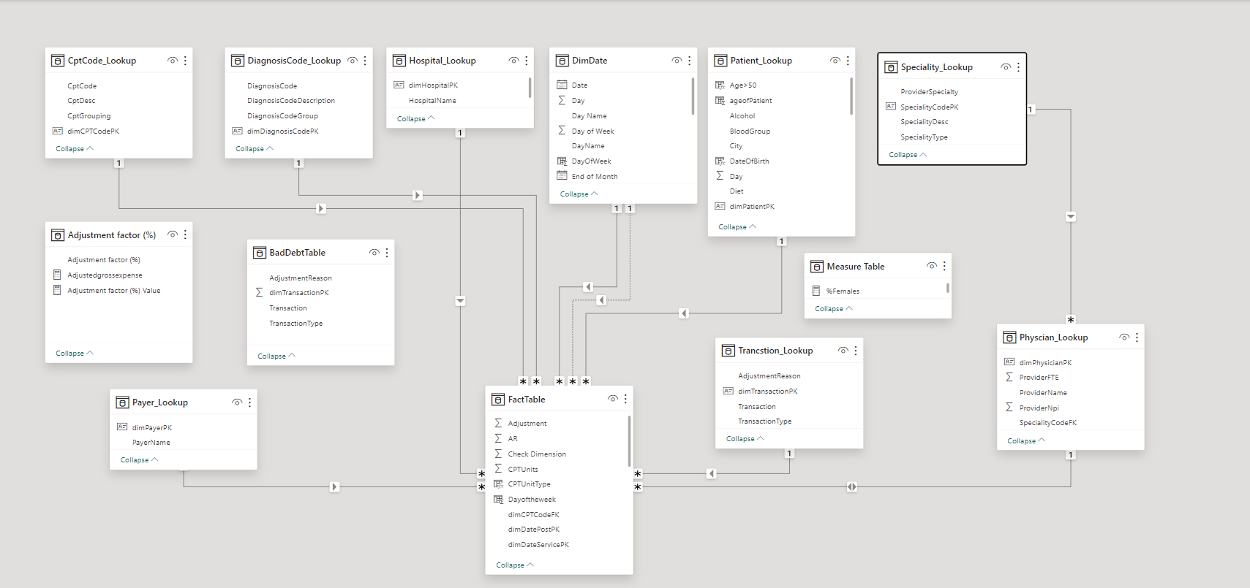

**CONCLUSION:**

The U.S. Healthcare Industry Dynamics project for 2019-2020 offers a comprehensive and insightful analysis of the healthcare landscape, utilizing advanced data analytics and visualization tools. Through meticulous data cleaning, DAX calculations, and interactive visualizations, this project provides valuable insights and strategic intelligence for healthcare stakeholders.

**Key Insights**

* **Enhanced Decision-Making:**
  + The interactive PowerBI dashboard facilitates informed decision-making by offering detailed and dynamic visualizations of key healthcare metrics.
  + Strategic insights into hospital performance, patient outcomes, and healthcare provider metrics aid in optimizing operational efficiency and improving patient care.
* **Hospital Performance Trends:**
  + Detailed analyses of patient admissions, discharge rates, and overall hospital efficiency reveal critical trends that healthcare administrators can leverage for better resource management.
* **Patient Outcome Analysis:**
  + Examination of patient demographics, treatment efficacy, and potential areas for medical intervention highlight opportunities for enhancing patient care and outcomes.
* **Financial Optimization:**
  + Insights into payer-provider relationships and monthly expense trends help identify potential areas for cost optimization and revenue enhancement.
* **Comprehensive Data Structure:**
  + The ER Diagram provides a clear understanding of the data architecture, supporting robust and accurate analyses.